CSC 271 Data Structures
Lab 8: Implementing sorted List as a Linked Nodes

- Add the following operation to the class orderedLinkedListType

void mergeLists(orderedLinkedListType<Type> &list1, orderedLinkedListType<Type> &list2) ;
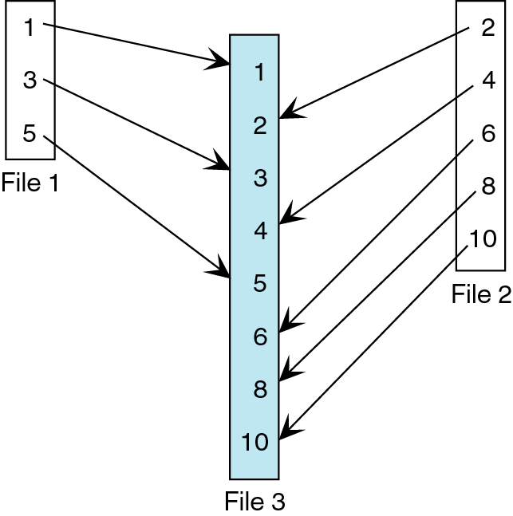
// This operation creates a new list by merging the
// elements of list1 and list2.
// Precondition: Both lists, list1, and list2, are ordered
// Postcondition: first points to the merged list,
// and lists list1, and list2 are empty.

Example:
orderedLinkedListType<int> newList ;
orderedLinkedListType<int> list1;
orderedLinkedListType<int> list2 ;

Assume list1 is 2, 6, 7, and list2 is 3, 5, 8.
The statement:

newList.mergeLists(list1, list2) ;

creates a new linked list with the elements in order 2, 3, 5, 6, 7, 8, and the object newList points to this list. Also, after the preceding statement executes, list1 and list2 are empty.

- The function insertNode of the class orederedLinkedListType does not check whether the item to be inserted is already in the list.
Rewrite the definition of insertNode so that before inserting the item it checks whether the item is already in the list. If the item to be inserted is already in the list, the function outputs an appropriate error message.

Note:
Use pointers to implement these operations.

- Write a test driver (.cpp) file to test all member and non-member functions.

What to submit
• The output of the test driver
• The test driver file
• New implemented functions from the .h file

